Test Number | Test Case Type | Description | Test Steps | Test Data | Expected Results | Actual Results | Status  (Pass/Fail)
1 | Functionality | This test is to check if program does indeed conform to UK format standard when it comes to national id, so using an incorrect id number when prompted for id number, then the checking if user gets prompted again for national id and when using the correct format, the program does indeed proceed onto the next step which is photo identification. | Traversing the application and attempting to create a customer, inserting a name, incorrect national id and then the correct national id. | Option “2” for sign up customer.  Option “1” continue sign up.  “John smith” as name, “123123” as national id.  “AA123123B” as national id. | The program should allow easy traversal to customer creation, then allow name to be inserted and when incorrect national id is inserted, an error message is prompted and then the program asks for the national id again, then inserting a correct formatted id, and proceeding to the next step of the creation which is photo identification. | The program allowed smooth traversal, and easy creation of customer name and national id, when incorrect formatted id was inserted, a error message was prompted and then program did ask again for the national id, when a correct formatted id was inserted, the program did indeed move onto the next step; photo identification. | Pass
2 | Functionality | Checking if the program goes back a step when exiting from create customer menu when trying to create a customer, leading back to main menu. | Traversing to create a customer and then exiting that menu to return to main menu. | Option “2” for sign up customer.  Option “0” back to main menu.  Viewing main menu. | The program should allow traversal to create customer and then allow traversal back to main menu. | The program worked as expected allowing the creation of a customer menu to be traversed to and then back to menu option working as intended. | Pass
3 | Functionality | Checking if the program goes back a step when exiting from photo identification menu when trying to create a customer, leading back to create customer menu. | Traversing to create a customer, inserting name, national id and then when prompted with the photo identification menu, cancelling operations and viewing the menu you get puto onto. | Option “2” for sign up customer.  Option “1” continue sign up.  “John smith” as name, “123123” as national id.  “AA123123B” as national id.  Option “0” to cancel operation.  Viewing create customer menu. | The program should allow traversal to create customer, allow insertion of customer name and national id, then proceeding to the photo identification menu, from there cancelling operations and returning to create customer menu. | The program did allow for creation of customer, insertion of information and then proceed as expected to the photo identification menu, from there the cancelling operations did return to create customer menu, so working as intended. | Pass
4 | Functionality | Testing to see if the program exits when attempting to close from the main menu with a prompted goodbye message. | Running the program and exiting immediately. | Option “0” for exit.  Viewing prompted goodbye message. | The program should exit and close when told to prompting a goodbye message. | The program did exit and close off with a goodbye message. | Pass
5 | Functionality | Purpose of this test is to see if inserting incorrect passport photo id number, the program prompts an error message and asks for a correct number. Then inserting a correct formatted answer and proceeding to the next menu to check if a valid formatted number is accepted. | Creating a customer, selecting passport as photo identification, inserting a incorrect formatted number, and then inserting a correct number. | Option “2” for sign up customer.  Option “1” continue sign up.  “John smith” as name, “123123” as national id.  “AA123123B” as national id.  Option “1” for passport.  “123123” as incorrect id number.  “123123123” as correct id number.  Viewing menu. | The program should allow for easy creation of customer, passport selection should be able to be selected; after inserting an incorrect value, program prompts error message and asks you enter correct information; after inserting correction information the program proceeds to the address menu screen. | The program worked as intended, allowing creation of customer until the point needed, the correct option being allowed to be selected, the incorrect formatted input being met with an error message and a new prompt for correct option, then insertion of correct response did proceed to the next step which is the address menu. | Pass
6 | Functionality | Purpose of this test is to see if inserting incorrect driving licence photo id number, the program prompts an error message and asks for a correct number. Then inserting a correct formatted answer and proceeding to the next menu to check if a valid formatted number is accepted. | Creating a customer, selecting driving licence as photo identification, inserting a incorrect formatted number, and then inserting a correct number. | Option “2” for sign up customer.  Option “1” continue sign up.  “John smith” as name, “123123” as national id.  “AA123123B” as national id.  Option “2” for driving licence.  “1234abcd” as incorrect id number.  “1234abcd1234abcd” as correct id number.  Viewing menu. | The program should allow for easy creation of customer, driving licence selection should be able to be selected; after inserting an incorrect value, program prompts error message and asks you enter correct information, after inserting correction information the program proceeds to the address menu screen. | The program worked as intended, allowing creation of customer until the point needed, the correct option being allowed to be selected, the incorrect formatted input being met with an error message and a new prompt for correct option, then insertion of correct response did proceed to the next step which is the address menu. | Pass
7 | Functionality | Trying to create a customer and using already existing customer’s national id, the purpose it to make sure that no duplicate customer with the same national id can exist and checking if national id request is prompted again.  Will be using a customer created from Test Number 1, where their national id is “AA1231213B”. | Creating a customer with already existing national id. | Option “1” continue sign up.  “John smith” as name.  “AA123123B” as national id. | Program should not allow a duplicate customer to be created whose national id already exists in the database, attempting to duplicate this should result in an error message and a return to the national id prompt. | The program went as expected, denying duplicate customer to be created and prompting user with an error message and then prompting for their nation id again. | Pass
8 | Functionality | Testing to see if return to customer portal, works as intended after a creation of a customer’s account. | Creating a new customer, when presented with the menu to open a new account, declining and returning to customer portal. | Option “2” for sign up customer.  Option “1” continue sign up.  “John Smith” as name.  “CC123123A” as national id.  Option “1” for passport.  “123123123” as passport photo id number.  Option “1” for utility address and using “123” as reference number.  Option “1” to confirm customer creation.  Option “2” to go to customer portal.  Viewing menu. | Expected result is for the program to allow creation of customer, then when presented with the option to open a new account; declining it and return to customer portal and seeing details of your created customer. | The program worked exactly as expected, allowing creation of customer and rejection of opening account, and showing customer information whilst being on the customer portal menu. | Pass
9 | Database | Testing to see if customer data is saved onto the database, so using the program to create a customer then exiting out and running a separate class designed to view all data to see customer’s existence. | Create a customer, then exit the program and run the data handling class to verify creation. | Option “2” for sign up customer.  Option “1” continue sign up.  “AA123123D” as national id.  Option “1” for passport.  “123123123” as passport photo id number.  Option “1” for utility address and using “123123” as reference number.  Option “1” to confirm customer creation.  Option “0” to go cancel account opening.  Option “0” to exit program.  Running data handling class and viewing database. | The program should allow for creation of customer and then exit of program, then to see the creation of customer, the data handling class which has a view method for the database should the creation of that customer when showing customer table. | The program did allow creation of customer with test data as customer data, exit of program went smoothly, and so did viewing of the customer’s data inside the database via the data handling class. | Pass
10 | Functionality | Testing to see if find a customer feature works, so checking the database for customers created during this test plan, and selecting one to use, grabbing their customer id and inserting it into the program to see if it is found. | Run data handling class to view database, select a customer to load, use that customer’s id; to find a customer in the main program. | Running data handling class and viewing database.  Option “1” find a customer.  “CUST000008” as customer id. | The database should load and you should be able to see customer’s ids and selecting one, then running up the program and using the find a customer feature with that id should make the program load the customer, stating it found it and loading the general information regarding that customer, ending on the accounts screen. | Database did hold customer information, selection of a customer’s id went smoothly, using the find a customer feature using that id also worked as expected, the program prompted saying “Customer Found”, listing their general information and then loading up the accounts menu. | Pass
11 | Functionality | Testing to see if when a customer is newly created, when going to view accounts feature, will it show no accounts have been made correctly and return user back to accounts menu from account selection menu, so trying to select an account when none exist should prompt an error message and a new menu that allows them to go back. | Run data handling class to view database, select a customer to load, use that customer’s id; to find a customer in the main program, then choose view accounts and attempt to select an account that does not exist. | Running data handling class and viewing database.  Option “1” find a customer.  “CUST000008” as customer id.  Option “1” to view accounts.  Option “1” to select account.  “1” for chosen account.  Option “0” to return to main account menu. | The program should allow for customer data to be loaded based on customer id, then it should allow the customer to view accounts, it should not allow further actions if no accounts exist, if attempting to select an account that does not exist goes through , the user should be prompted a error message and be allowed to return to the main account menu. | The program allowed for customer’s data to be loaded in, viewing accounts worked as intended, selection of accounts that do not exist did end in an error message being prompted and the ability to traverse back to the main account menu succeeded. | Pass
12 | Functionality | Using “John Helix” as the customer profile, attempting to open an ISA account and viewing all accounts to display the creation of that account. | Open an account from view accounts menu, select ISA as the account to open, set initial balance to zero and then view all accounts to see creation. | Option “2” to open account.  Option “2” for ISA account.  Option “1” to set initial balance to “0”.  Option “1” to confirm.  Option “1” to view accounts. | Using preset customer profile already loaded in the program should allow for creation of an ISA account with zero balance and then the view of that account. | The program correctly allowed creation of the ISA account, and viewing of it with verification of opening balance of “0” using preset customer profile. | Pass
13 | Functionality | Using “John Helix” as the customer profile, attempting to open a second ISA account, the program should reject attempts to open more than one, allowing the user to return to main account menu whilst being prompted with an error message. | Open account, select ISA account and then return to main account menu. | Option “2” for opening account.  Option “2” for ISA account.  Pressing enter to return to menu. | Using the preset customer profile, the program should allow for opening of new account, then when attempting to create a new ISA account with already existing ISA account, the program should prompt an error message and allow them to return to the main account menu. | The program allowed to open a new account, and when attempting to open a second ISA account the program correctly rejected that attempt and prompted an error message with the ability to return to the main account menu. | Pass
14 | Functionality | Using “John Helix” as the customer profile, attempting to open a business account and viewing all accounts to display the creation of that account, the account should be given a initial balance of £0, and when viewing it should display -£120, meaning we have overdraft working and £120 annual fee being applied automatically. | Open an account from view accounts menu, select business as the account to open, set initial balance to zero and then view all accounts to see creation. | Option “2” to open account.  Option “2” for business account.  Option “1” to set initial balance to “0”.  Option “1” to confirm.  Option “1” to view accounts. | Using preset customer profile already loaded in the program should allow for creation of a business account with zero balance and then the view of that account should tell us the balance is -£120. | The program correctly allowed creation of the business account, and viewing of it with verification of opening balance of -£120 using preset customer profile. | Pass
15 | Functionality | Using “John Helix” as the customer profile, attempting to open a second business account, the program should reject attempts to open more than one, allowing the user to return to main account menu whilst being prompted with an error message. | Open account, select business account and then return to main account menu. | Option “2” for opening account.  Option “3” for business account.  Pressing enter to return to menu. | Using the preset customer profile, the program should allow for opening of new account, then when attempting to create a new business account with already existing business account, the program should prompt an error message and allow them to return to the main account menu. | The program allowed to open a new account, and when attempting to open a second business account the program correctly rejected that attempt and prompted an error message with the ability to return to the main account menu. | Pass
16 | Functionality | Using “John Helix” as the customer profile, attempting to create a personal account with a balance of 0, this is testing the rule of personal accounts needed at least £1 to be allowed to open. | Open account, select personal account, setting initial balance to £0 then returning to main account menu. | Option “2” to open account.  Option “1” for personal account.  Option “1” to set initial balance.  “0” being the balance value.  Option “0” to cancel operations. | Using the preset customer profile, the program should allow creation of personal account up until the attempt to open with a starting balance of zero, this should prompt and error message and allow the user to return to the main account screen. | The program allowed for smooth creation of personal account and correct error message prompt, but when it came to attempting to return to the main account menu, cancelling operations did not return the program to that point, instead if returned it to the main menu. | Fail
17 | Functionality | Using “John Hellix” as the customer profile, attempting to create a customer profile with an opening balance of £30, then verifying the creation of this by viewing all accounts. | Open account, select personal account, initial balance setting to £30, returning to main account menu and viewing the new account created with correct opening balance. | Option “2” to open account.  Option “1” for personal account.  Option “1” to set initial balance to “30”.  Option “1” to confirm creation.  Option “1” to view all accounts and verify balance. | Using the preset customer profile, the program should let you create a personal account, and set the balance to £30, then return you to main account menu and allow you to verify the changes from view account option. | The program succeeded in allowing personal account creation, correctly allowing balance setup, and the return to main account menu, further allowing the verification of this process by viewing the changes made from view accounts feature. | Pass
18 | Functionality | Using “John Helix” as the customer profile, attempting to withdraw past the overdraft limit for the business account, which has been set to £10000, after the error the user should be able to return to account selection view. | View accounts, selectin business account, attempt to withdraw £10000. | Option “1” view accounts.  Option “1” selection account, Option “2” for business account.  Option “2” withdraw “10000” pounds.  View error message and option “0” to return to account list. | Using the preset customer profile, the program should let you select the business account and let you insert a number that would cause the overdraft limit to be surpassed, once surpassed the program should prompt the user with an error message stating the clear limits of overdraft, how much they can withdraw and then allowing them to return to the account selection view to verify that the business account still has a balance of -£120. | The program worked as intended, allowing selection of business account and the ability to attempt to withdraw an exceeding overdraft value, the program then expectedly responded with an error message, stating the remaining overdraft withdrawal available and then allowing the program to be returned to the account selection view and verification of the changes not made to balance went as expected. | Pass
19 | Functionality | Using “John Helix” as the customer profile, trying to test if the deposit feature of the program works, so depositing into the business account and then view the account to see the changes made. | View accounts, select business account, deposit money, return to account view selection to verify changes. | Option “1” view accounts.  Option “1” selection account.  Option “2” for business account.  Option “1” to deposit.  “150” pounds deposited.  Option “0” to return to accounts list.  View and verify changes. | Using the preset customer profile, the program should let you view accounts, select the business account and then deposit £150, bringing the new balance to £30, returning to account selection view to verify the changes made. | The program worked as expected, allowing the viewing of accounts, the selection of the business account with the deposit feature working as intended, lastly allowing the return to accounts view selection to see changes made to balance, verify the new balance being £30. | Pass
20 | Functionality | Using “John Helix” as the customer profile, testing to see if withdrawing from an account feature functions, so viewing accounts; selecting personal account and then withdrawing money, then returning to account selection view to verify changes made. | View accounts, selectin account, select personal account, withdraw £10, return to account select view and verify changes. | Option “1” view accounts.  Option “1” select account.  Option “3” for personal account.  Option “2” to withdraw “10” pounds.  Option “0” to return to account selection view.  Verify changes made. | The program should let you view accounts, select personal account, withdraw £10 and then let you return to account view to verify the new balance of £20. | Working as expected, allowing viewing of accounts, selection of personal account, withdrawal of £10 and then the return to account selection view to see the new balance for the personal account at £20. | Pass
21 | Functionality | Using “John Helix” as the customer profile, testing to see if view transactions feature works, based on previous successful tests, using the personal account which has had a successful transaction with withdrawal, seeing the transaction made then returning to main account menu. | View accounts, select account, select personal account, view transactions, return to main account menu. | Option “1” to view accounts.  Option “1” to select account, “3” for personal account.  Option “3” to view transactions.  Option “0” return to main account menu, | Using “John Helix” as the customer preset profile, the program should let you view accounts, select personal account, view transactions and see the withdrawal from test number 20 of £10, seeing the withdrawal and the new balance, then the program should let you return to the main account menu. | As intended; the program allowed for viewing accounts, selecting of personal account, viewing transaction history and seeing the £10 withdrawal with the updated balance being displayed and then being allowed to return to the main account menu. | Pass
22 | Database | Using the “John Helix” as the customer profile, check the database to see their transaction history based on previous testing, this will verify that from test 18, the attempt to withdraw £10000 was not saved to the transaction table, from test number 19 seeing the deposit of £150 and then from test 20 seeing the withdrawal of £10.  Furthermore, this test should reveal that no direct debit or standing orders exist for “John Helix” | Run data handling which has a view all table method to view the database. | Run data handling class. | The program should display all data regarding customer “John Helix”’, their transaction history, lack of direct debits and standing orders. | The test went as expected, allowing viewing of the database, showing the transaction from mentioned tests and a lack of the transaction history for error-based attempts which was expected, then viewing the lack of standing orders and direct debits, | Pass

Test notes:
For tests stating that “John Helix” is the customer profile being used, know that the test data will not indicate the steps taken to load the profile, look at test number 10’s test data to see raw data on how to load the profile.
Still need to test sort code generation conforming to set standards the project has set, testing standing orders, direct debits, cheques issued and more, every instance of back returns to a maintainable menu, database and usability (help features).
Test number 1
Step 1 | Sign up customer:
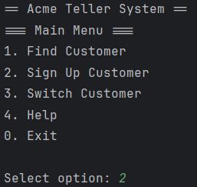
Step 2 | Continue with sign up:
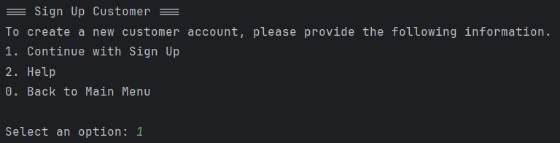
Step 3 | Inserting name and incorrect national id:
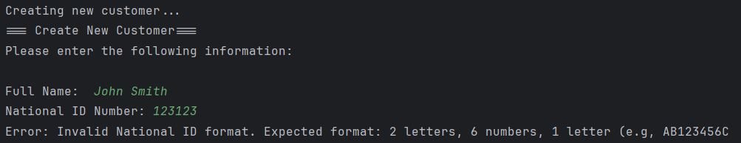
Step 4 inserting correct national id and moving onto the next screen:
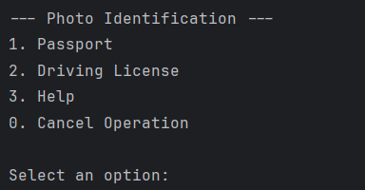
Test 2
Step 1 | Sign up customer:
Step 2 | Exiting sign-up customer menu:
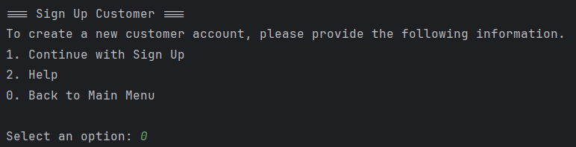
Step 3 | Viewing main menu:
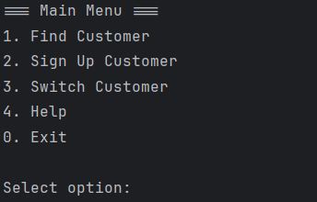
Test 3
Step 1 | Sign up customer:
Step 2 | Continue with sign up:
Step 3 | Inserting name and national id:
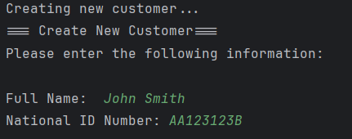
Step 4 | Exiting photo identification:
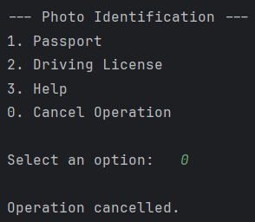
Step 5 | Viewing create customer menu:
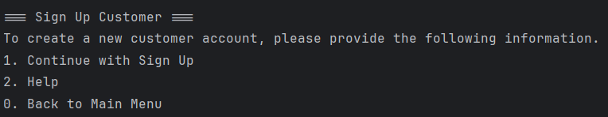
Test 4
Step 1 | Exiting and viewing goodbye message:
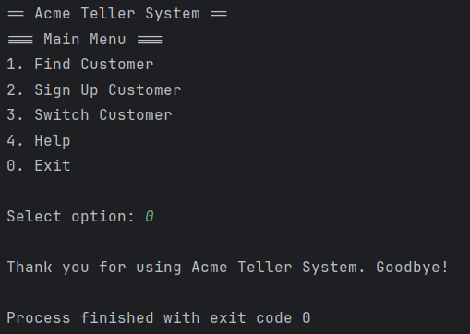
Test 5
Step 1 | Sign up customer:
Step 2 | Continue with sign up:
Step 3 | Inserting name and national id:
Step 4 | Selecting passport:
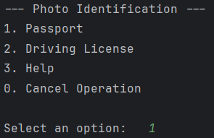
Step 5 | Inserting incorrect value:
Step 6 | Inserting correct value and seeing address menu:
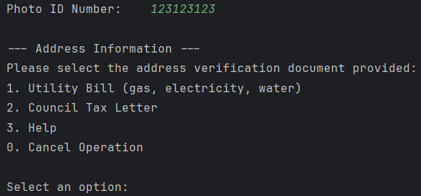
Test 6
Step 1 | Sign up customer:
Step 2 | Continue with sign up:
Step 3 | Inserting name and national id:
Step 4 | Selecting driving licence:
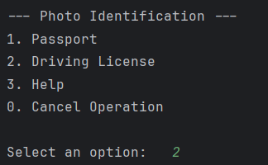
Step 5 | Inserting incorrect value:
Step 6 | Inserting correct value and seeing address menu:
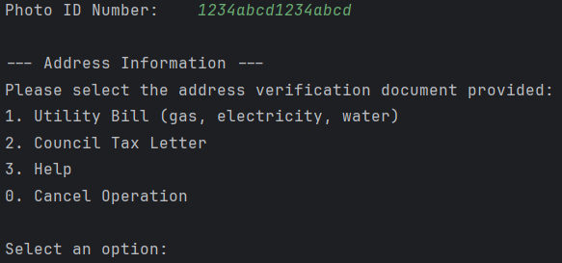
Test 7
Step 1 | Sign up customer:
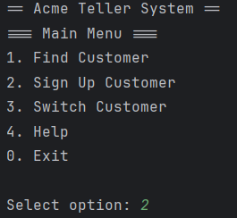
Step 2 | Continue with sign up:
Step 3 | Inserting name and national id:
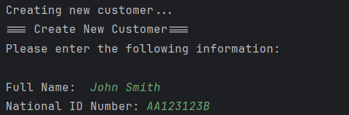
Step 4 | Viewing error message and new prompt:

Test 8
Step 1 | Sign up customer:
Step 2 | Continue with sign up:
Step 3 | Inserting name and national id:
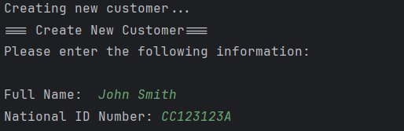
Step 4 | Selecting passport option and inserting id number:
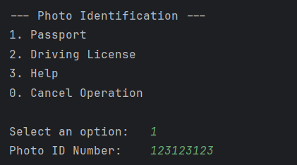
Step 5 | Selecting utility address option and inserting reference number:
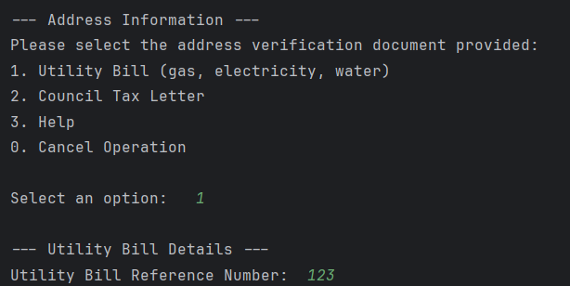
Step 6 | Confirm creation of customer:
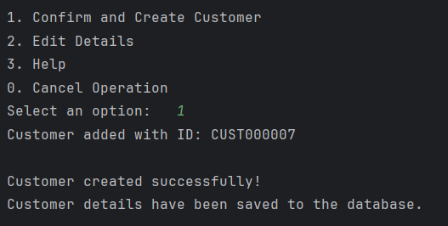
Step 7 | Returning to customer portal:
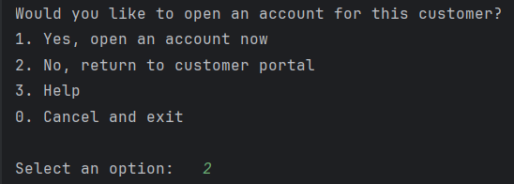
Step 8 | Viewing menu:
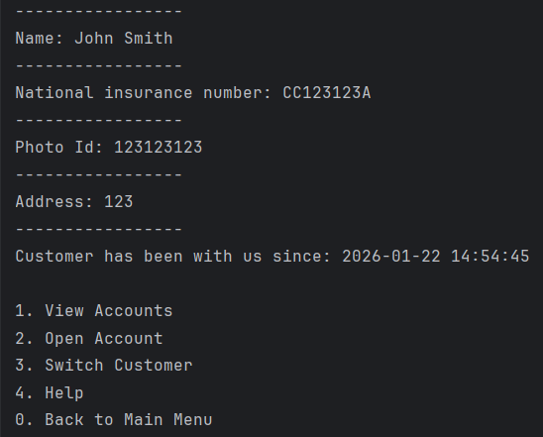
Test 9
Step 1 | Sign up customer:
Step 2 | Continue with sign up:
Step 3 | Inserting name and national id:
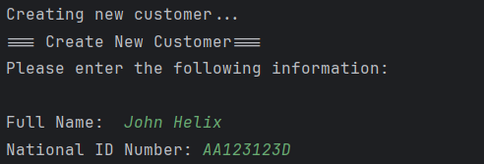
Step 4 | Selecting passport option and inserting id number:
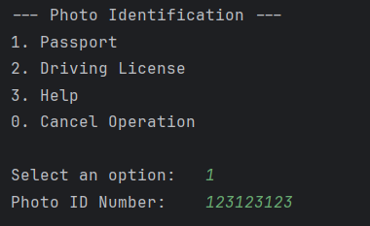
Step 5 | Step 5 | Selecting utility address option and inserting reference number:
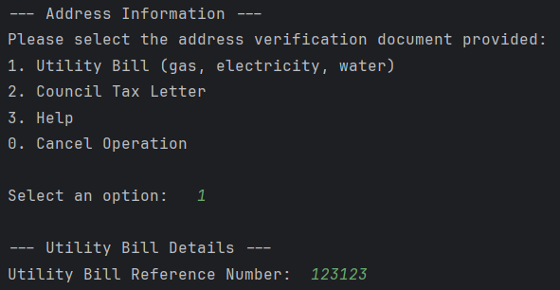
Step 6 | Confirm creation of customer:
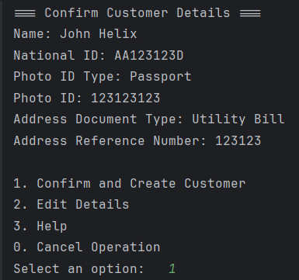
Step 7 | Exiting customer account setup:
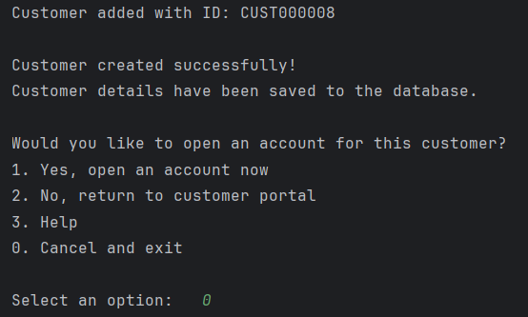
Step 8 | Exiting program:
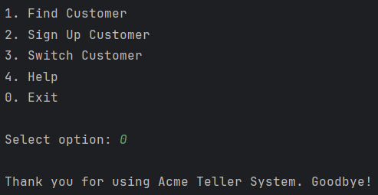
Step 9 | Running data handling class and viewing database
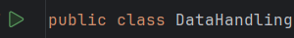
Test 10
Step 1 | Running data handing class and viewing database and selecting a customer:
Step 2 | Running the main program and choosing to find a customer:
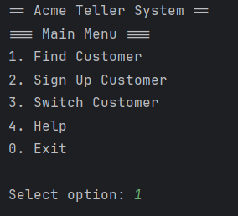
Step 3 | Inserting chosen customer’s id:
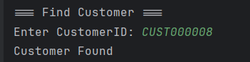
Step 4 | Viewing loaded customer’s information:
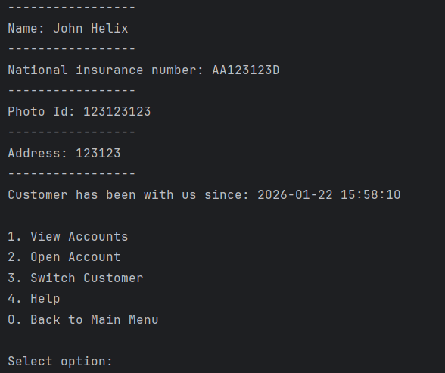
Test 11
Step 1 | Running data handing class and viewing database and selecting a customer:
Step 2 | Running the main program and choosing to find a customer:
Step 3 | Inserting chosen customer’s id:
Step 4 | Viewing loaded customer’s information:
Step 5 | Selecting view accounts:
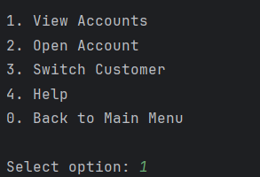
Step 6 | Trying to select non existing account after error message:
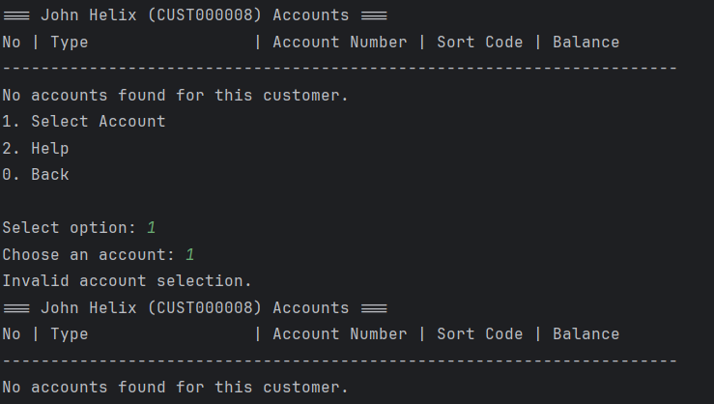
Step 7 | Attempting to back to main account menu:
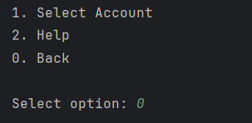
Step 8 | Viewing main account menu:
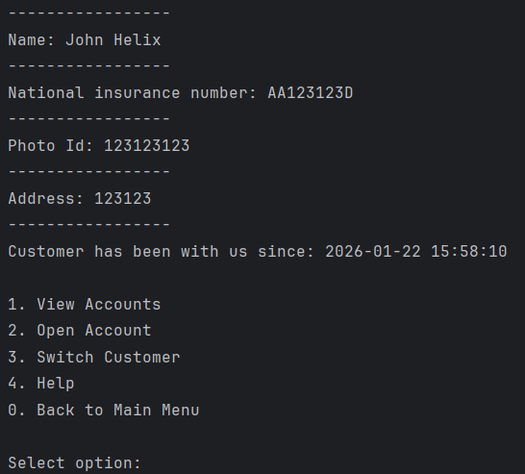
Test 12
Step 1 Viewing loaded customer profile and opening account:

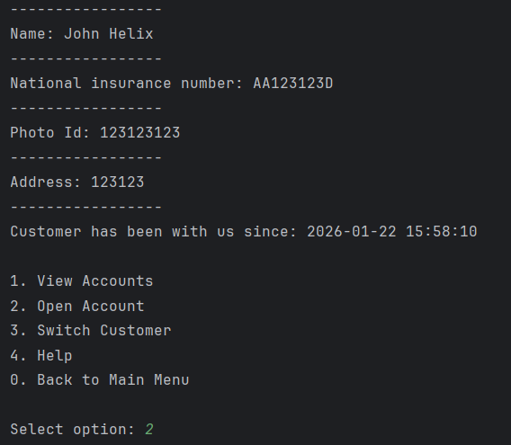
Step 2 | Selecting ISA account:
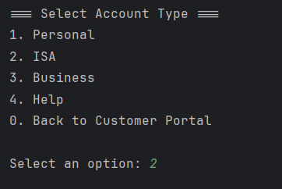
Step 3 | Setting initial balance to £0:
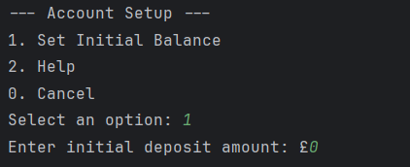
Step 4 | Confirming decision:
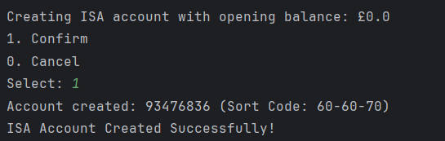
Step 4 | Viewing account:
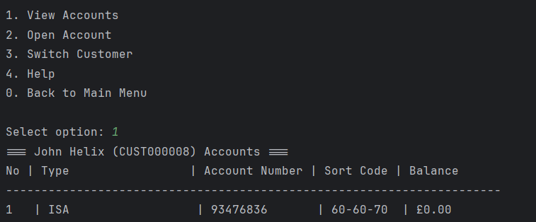

Test 13
Step 1 | Opening account option selected:
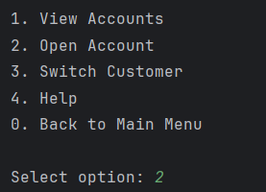
Step 2: Selecting ISA account:
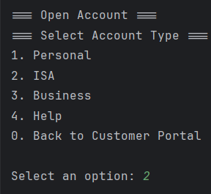
Step 3 | Error message being prompted, hitting enter to return to main menu:
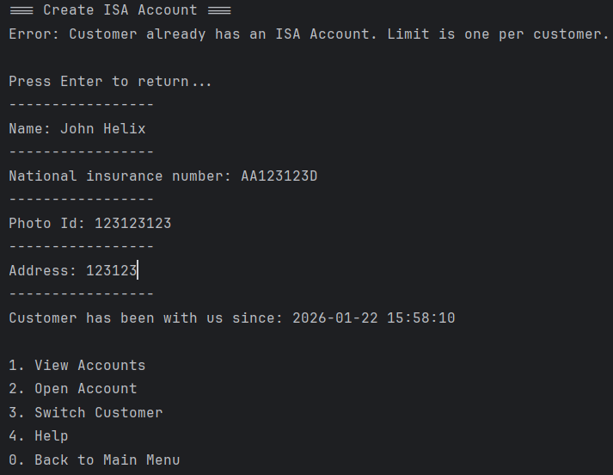
Test 14
Step 1 | Opening account:
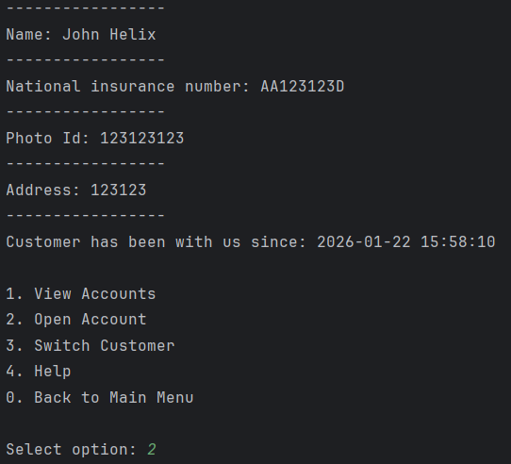
Step 2 | Selecting business account type:
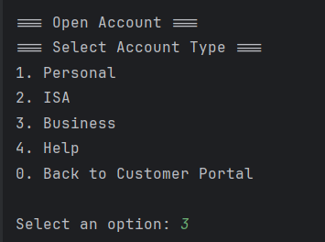
Step 3 | Setting initial balance to 0:
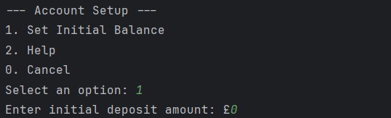
Step 4 | Confirming creation:
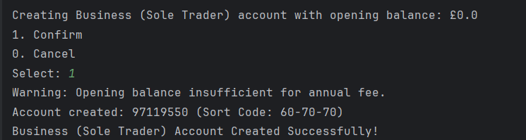
Step 5 | Selecting view accounts:
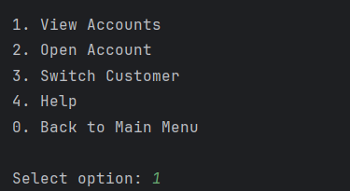
Step 6 | Viewing account created with balance shown:
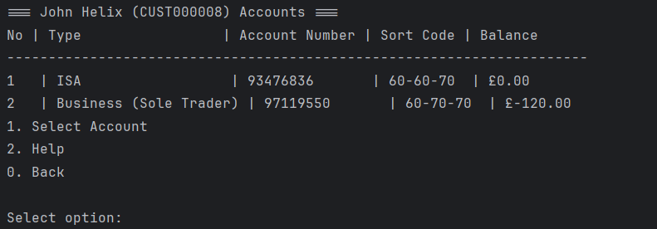
Test 15
Step 1 | Opening account:
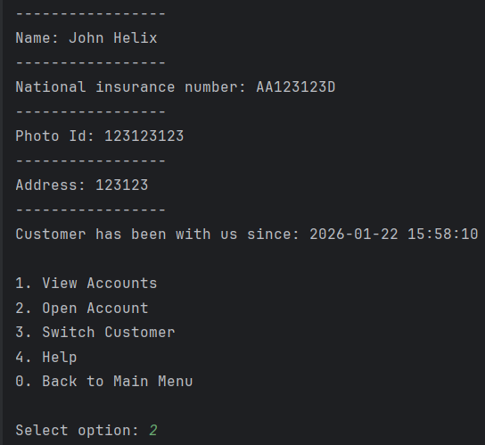
Step 2 | Selecting business account type:
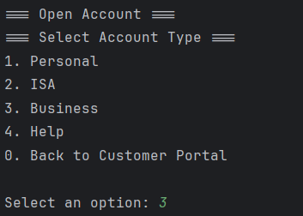
Step 3 | Viewing error message and hitting enter to return to main account menu:
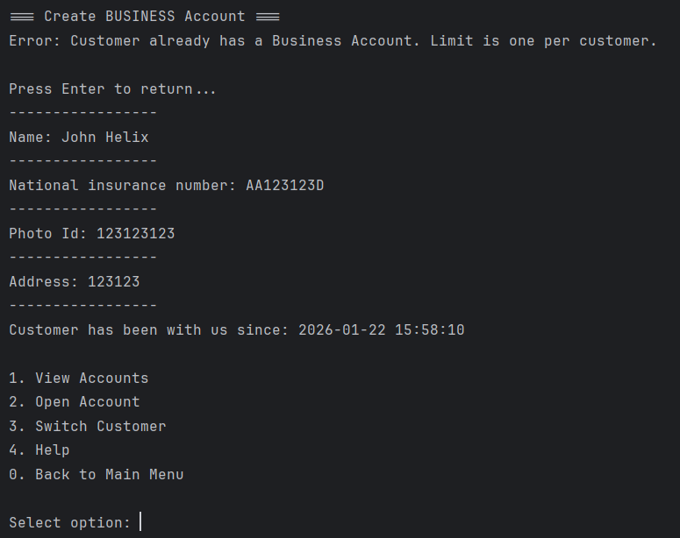
Test 16
Step 1 | Opening account:
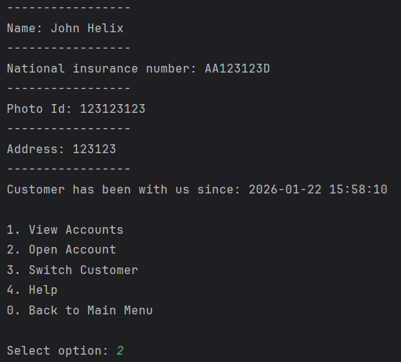
Step 2 | Selectin personal account type:
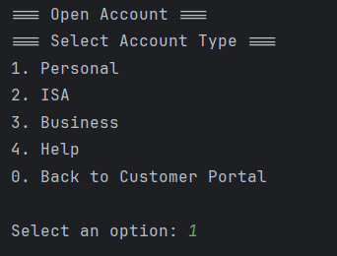
Step 3 | Setting initial balance to £0:
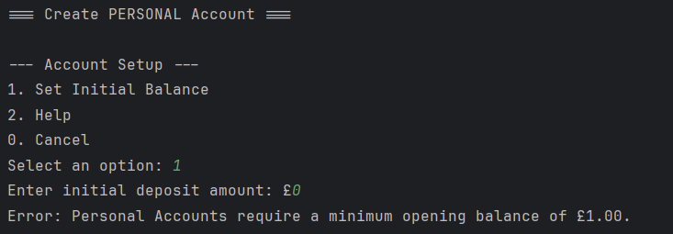
Step 4 | Cancelling account setup:
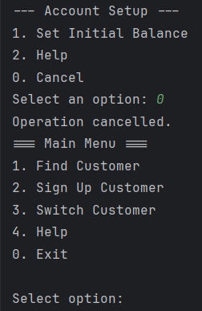

Test 17
Step 1 | Opening account:
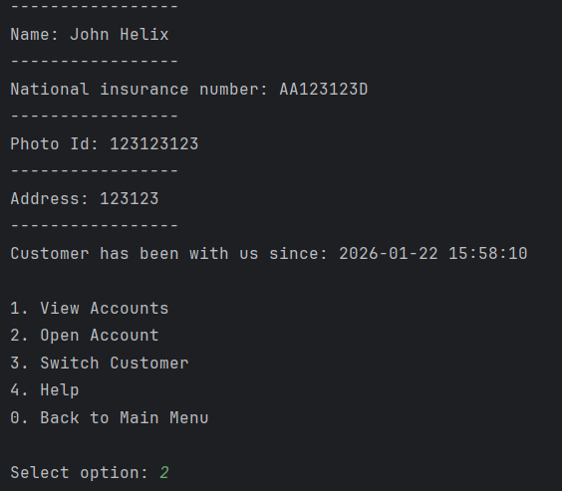
Step 2 | Selecting personal account type:
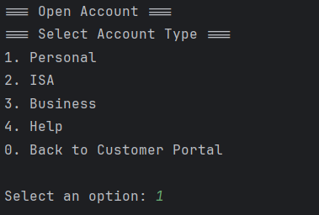
Step 3 | Setting initial balance to £30 :
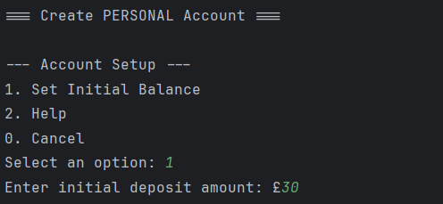
Step 4 | Confirming creation:
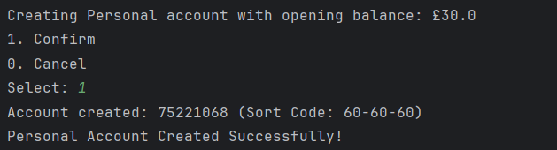
Step 5 | Selecting view accounts:
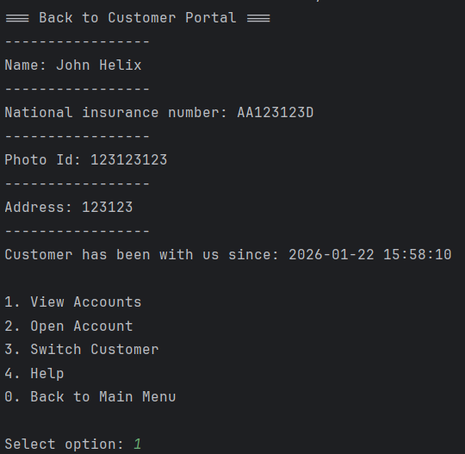
Step 6 | Viewing account creation with correct initial balance:
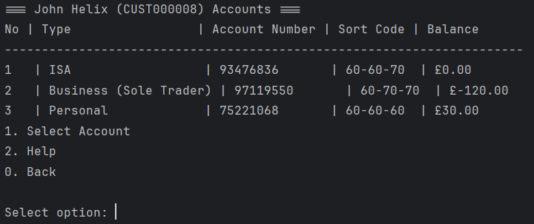
Test 18
Step 1 | View account:
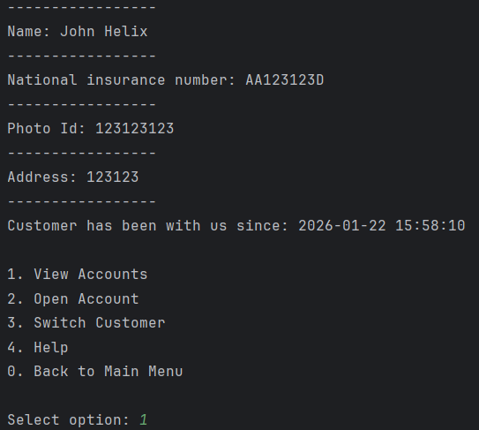
Step 2 | Select business account:
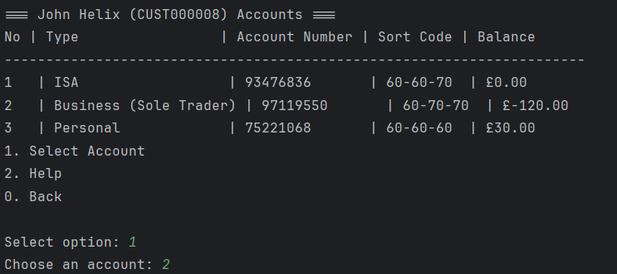
Step 3 | Withdraw £10000, and view error message:
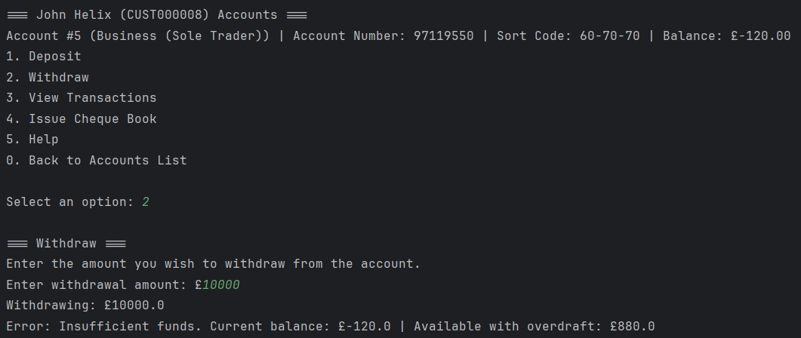
Step 4 | Return to account selection view and verify changes not made:
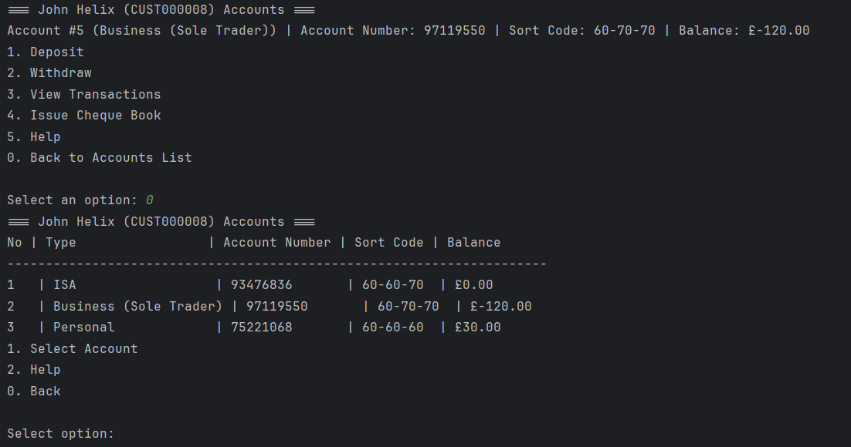
Test 19
Step 1 | View account:
Step 2 | Select business account:
Step 3 | Deposit £150:
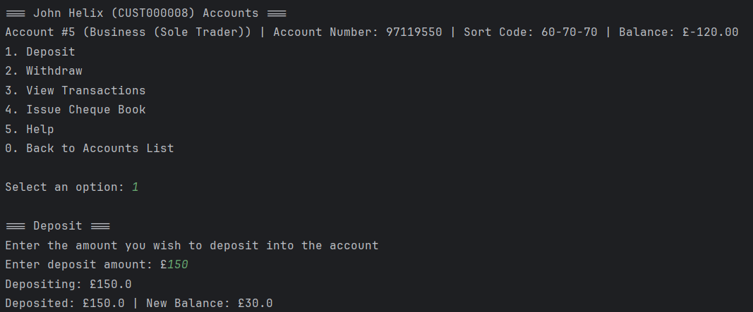
Step 4 | Return to account selection view and verify changes made:
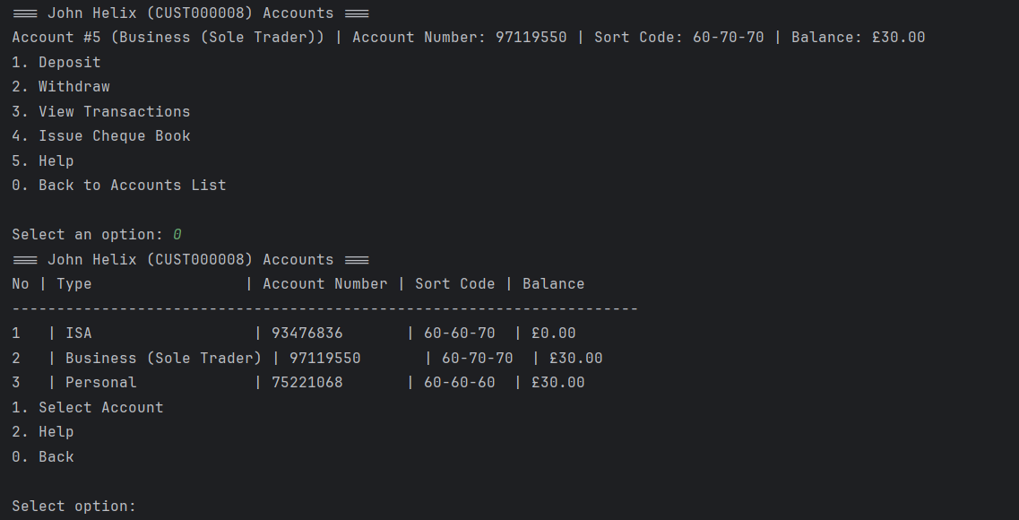
Test 20
Step 1 | View account:
Step 2 | Select personal account:
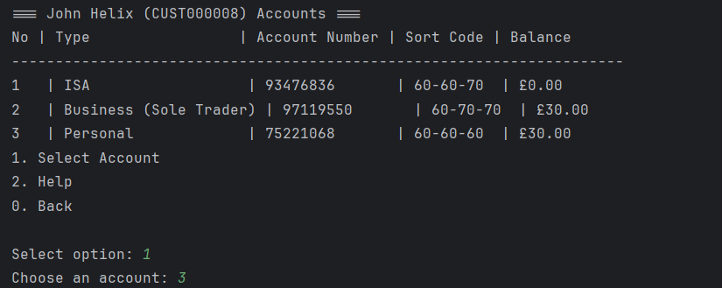
Step 3 | Withdraw £10:
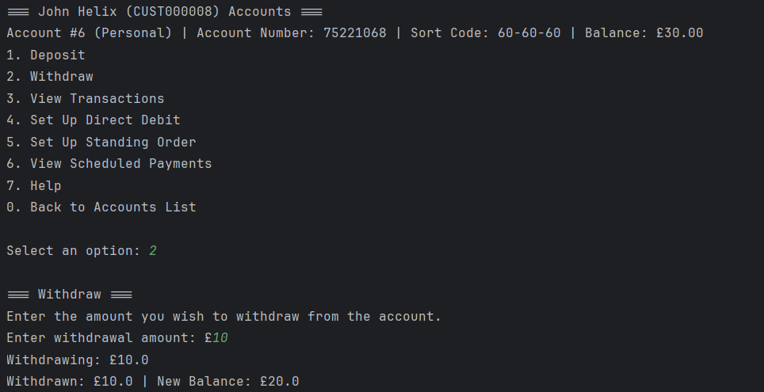
Step 4 | Return to account selection view and verify changes made:
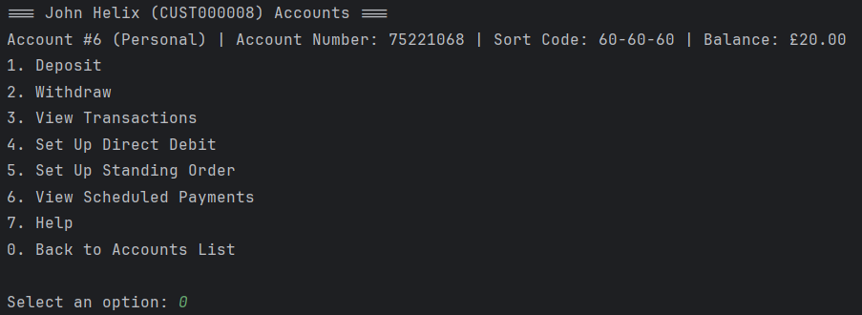
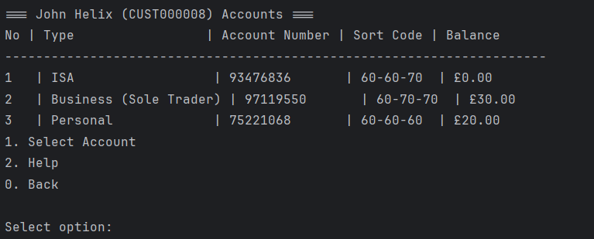
Test 21
Step 1 | View accounts:
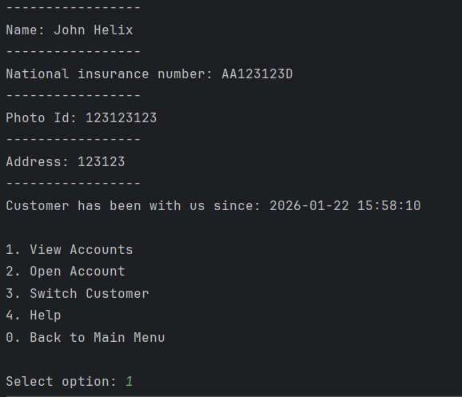
Step 2 | Selecting personal account:
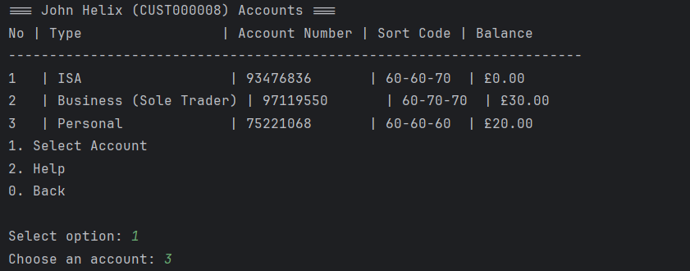
Step 3 | Selecting view transactions option:
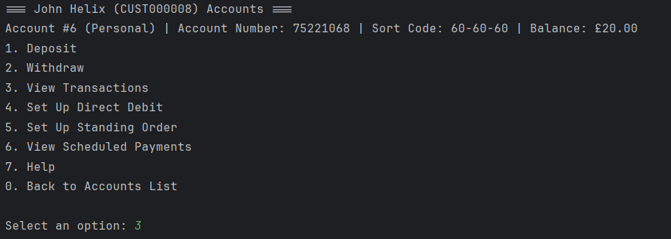
Step 4 | Viewing transactions then returning to main account menu:
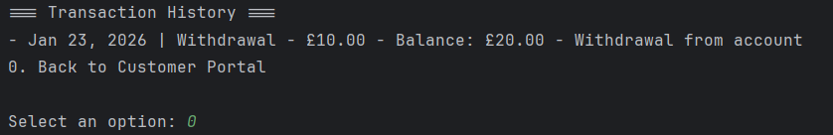
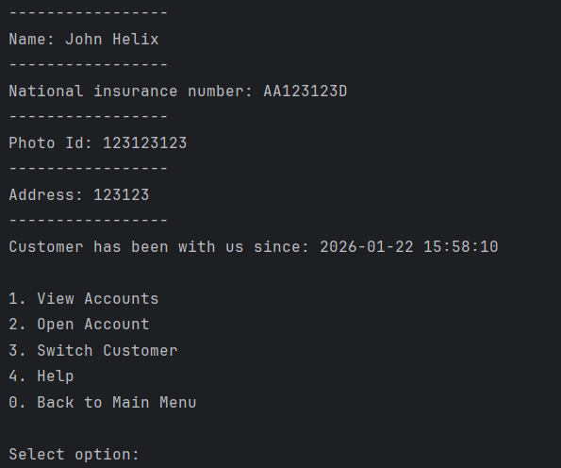
Test 22
Step 1 | Runing data handling class:

Step 2 | Viewing transactions customer profile should have:
Step 3 | Viewing standing orders and direct debits:
